**DEPARTMENT OF INFORMATION TECHNOLOGY**

**Course: DSA Lab( ITL302)**

**B.Tech. (Information Technology) – Semester III**

**Academic Year: 2024-25 (Odd Semester)**

**Experiment No: 9**

**Aim:** Implementation of Binary Search Technique considering a real-world application.

**Code:**

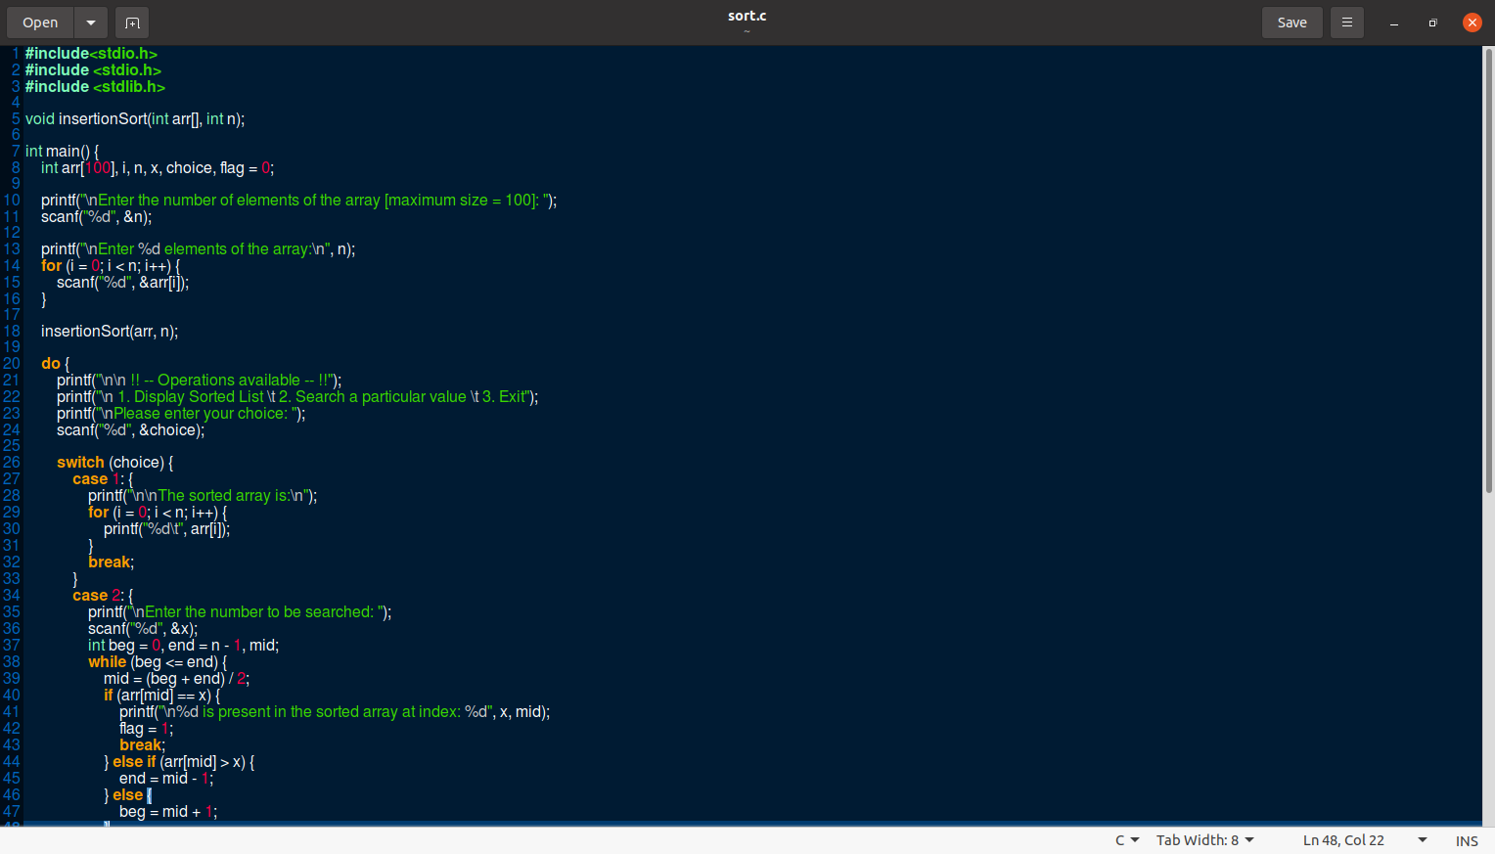

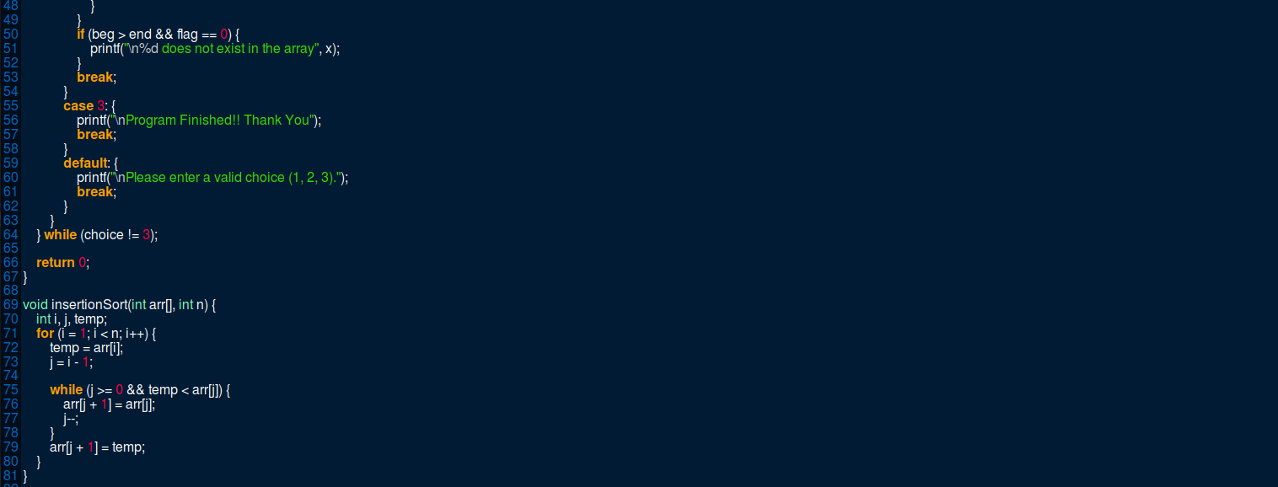

**Output:**

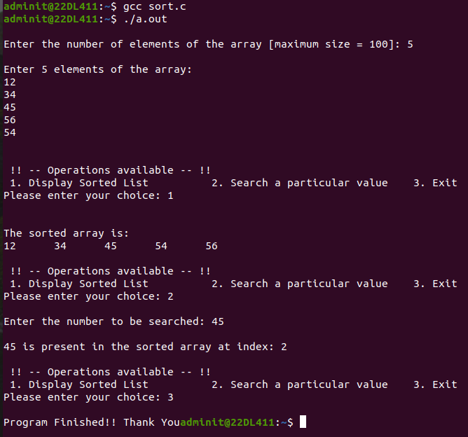

**Submitter Details -**

**Name of Student:** Subroto Datta

**Roll No.:** 17

**Date of Performance:** 27/09/2024

**Date of Submission:** 27/092024